ELASTIC BLOCK STORAGE

**Amazon Elastic Block Store (EBS)** is Amazon’s block-level storage solution used with the **EC2** cloud

service to store **persistent data**. [This means that the data is kept on the AWS EBS servers even when](https://docs.aws.amazon.com/ebs/latest/userguide/what-is-ebs.html) [the EC2 instances are shut down.](https://docs.aws.amazon.com/ebs/latest/userguide/what-is-ebs.html) EBS provides scalable, high-performance block storage resources that you can attach to Amazon EC2 instances

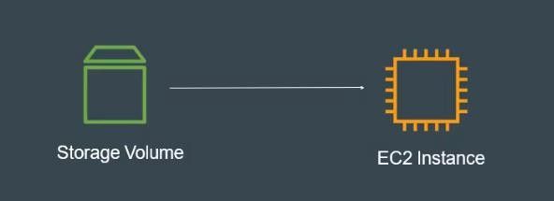

**Create EBS and attach EBS to 3 different instances:**

Step1: Go AWS console and create an EC2 instance. I was named as ec1 and created availability zone in Central region as shown in below.

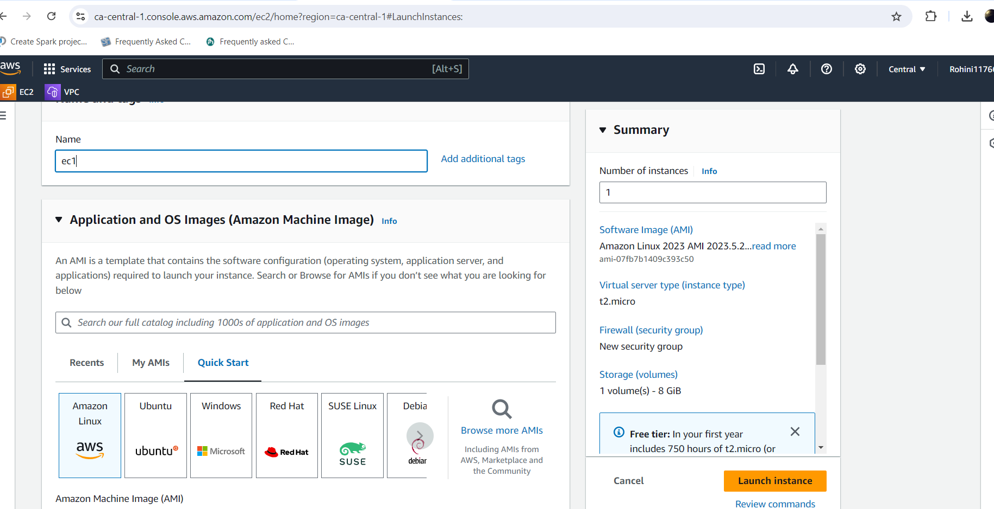

Once created the instance copy the ssh command and connect with that in git bash to the server.

After that change to the root user with sudo -i command and then check the disk free space with the command df -h as shown in below. In AWS EC2 instance have 8GB default storage.

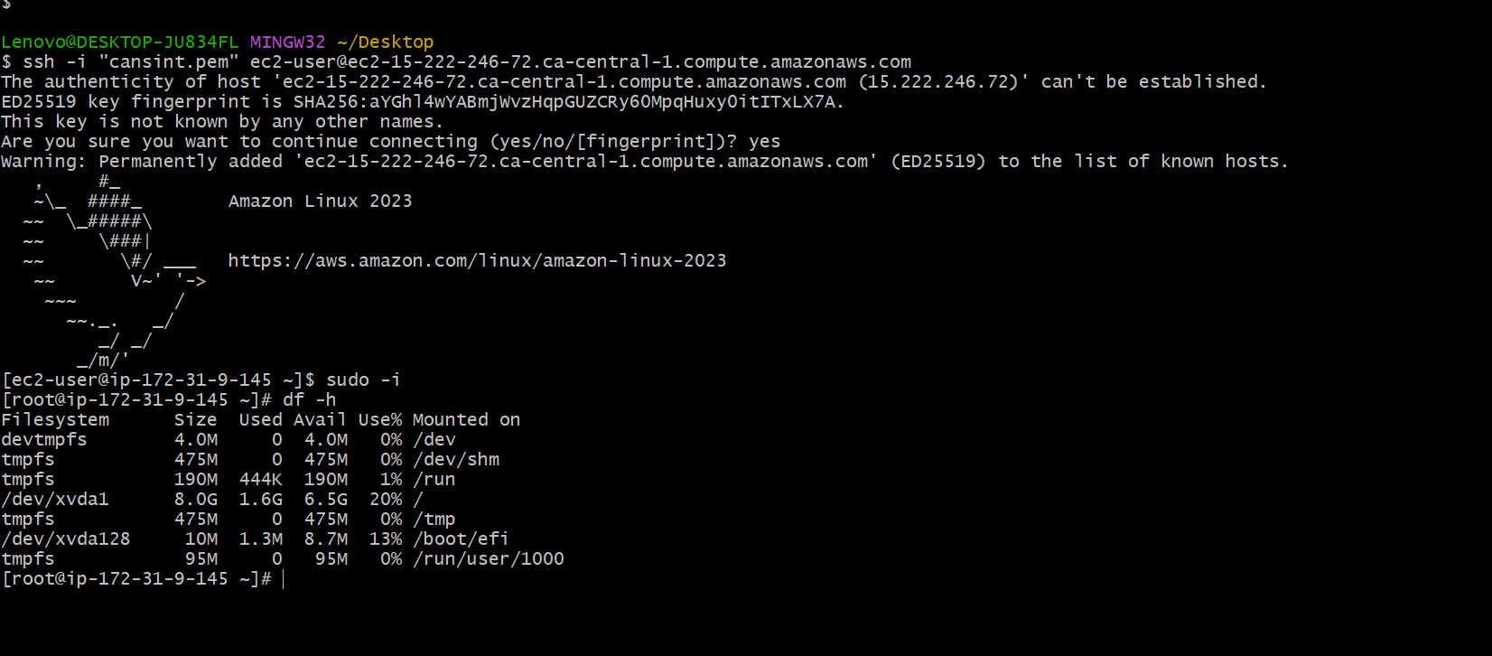

Step 2: Go to Elastic block store and click on volumes as shown in below.

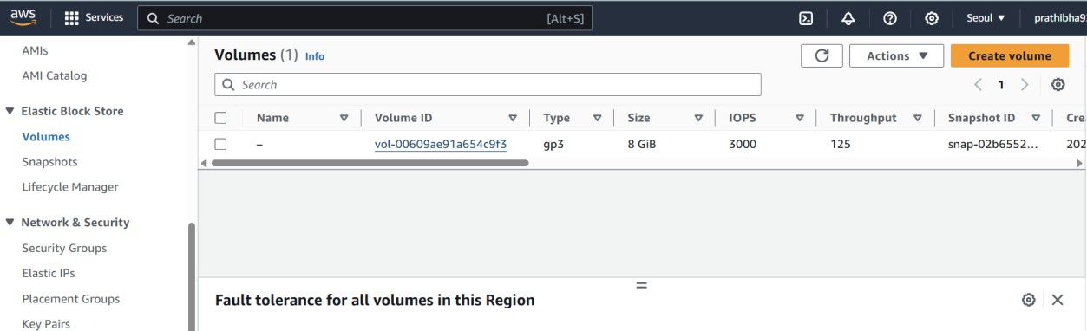

Click on create volume and configure the settings as shown in below diagram.

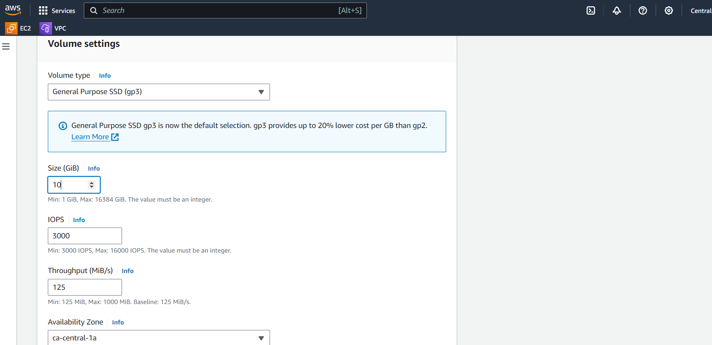

I was created the volume with 10GiB.once created the volume attach the volume to the EC2 instance(instance 1). Ec2 instance and created EBS volume should be same availability zone then only we can able to attach the volume to the EC2 instance.

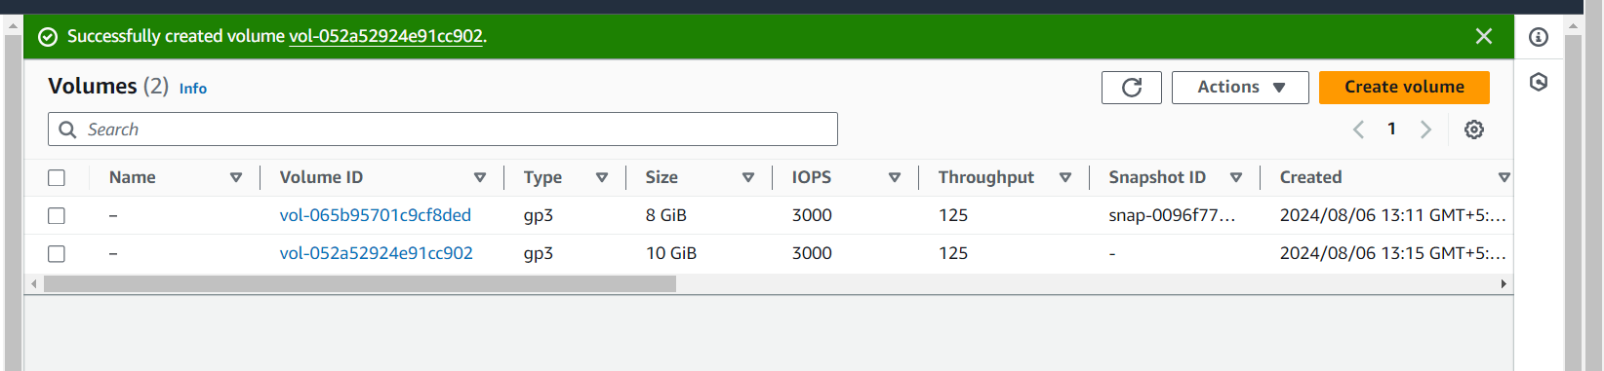

Now for EC2 instance total storage will be 18GiB(8 GiB default storage+10 GiB attached volume).

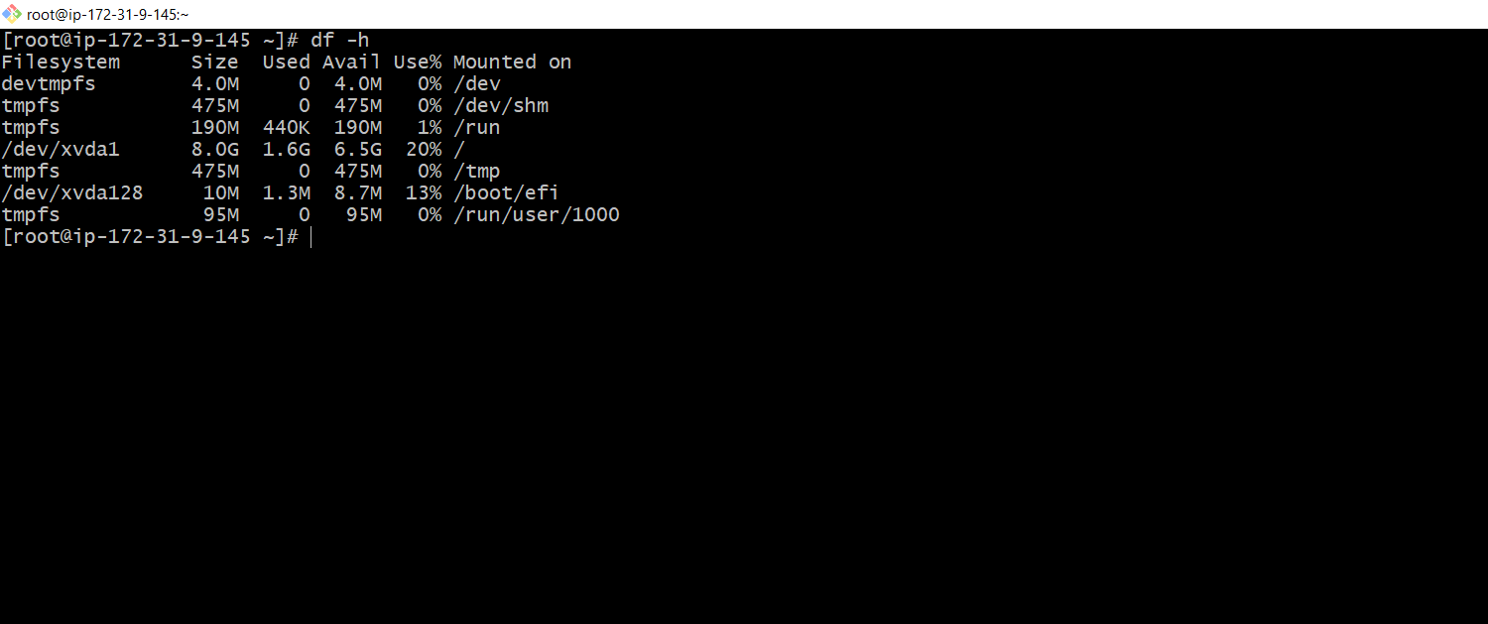

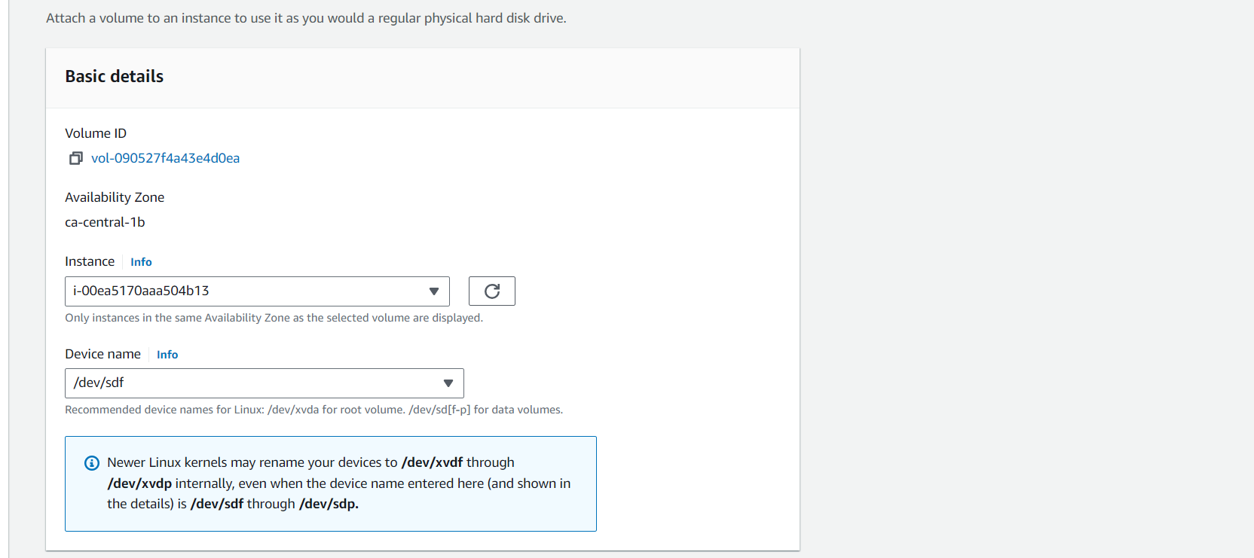

Attached volume will be available in block storage, for checking that storage in git bash use lsblk command.

For checking is there any file system in device ->file -s /dev/xvdf

For creating file system ->mkfs -t xfs /dev/xvdf

Creating a nested directory->mkdir -p apps/volume

For mounting the storage block storage to the root storage, we need to use mount /dev/xvdf apps/volume.

After mounting the storage total output storage for the root user is 18 GiB as shown in below.

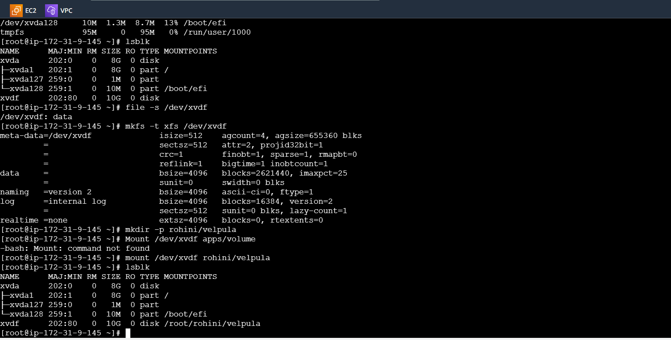

Step3:Create another instance in AWS console and names as ec2 as shown in below

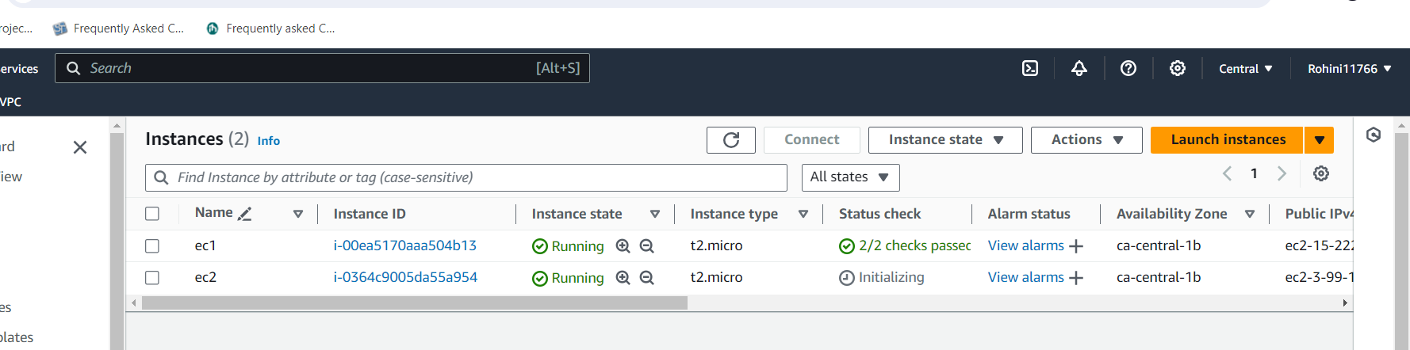

Once created the instance try to attach the instance to the EBS volume but can’t able to attach as shown below it will be disables because the EBS volume attached with instance 2. At a time, we can’t able to attach multiple EC2 instances to the same EBS volume. But we detach the EBS volume from

the instance 1 and able to attach to the instance 2 as shown in below diagrams.

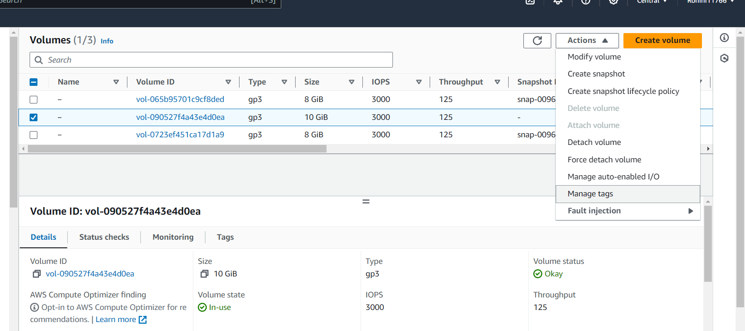

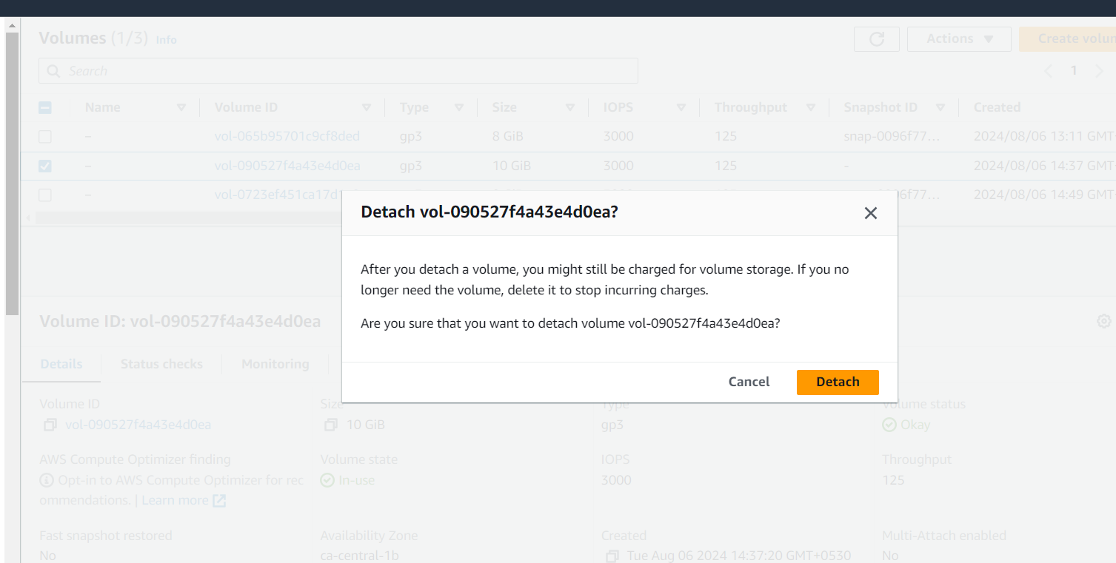

Like wise we need to create another EC2 instance and attach to the EBS volume after detaching from the instance 2.

**Conclusion:**

* Elastic block storage is a scalable, high-performance and block storage service designed for amazon EC2 and it can be attached or detach from EC2.
* EBS and EC2 instances both are in same availability zone only we can able to attach or detach the volume.
* Multiple EBS can attach to the single EC2 instance but multiple EC2 instances can’t able to attach to the same EBS.